# **CUSTOMER SEGMENTATION**

Customer segmentation is the practice of dividing a customer base into groups of individuals that are similar in specific ways relevant to marketing, such as age, gender, interests and spending habits.

Companies employing customer segmentation operate under the fact that every customer is different and that their marketing efforts would be better served if they target specific, smaller groups with messages that those consumers would find relevant and lead them to buy something. Companies also hope to gain a deeper understanding of their customers' preferences and needs with the idea of discovering what each segment finds most valuable to more accurately tailor marketing materials toward that segment.

Customer segmentation relies on identifying key differentiators that divide customers into groups that can be targeted. Information such as a customers demographics (age, race, religion, gender, family size, ethnicity, income, education level), geography (where they live and work), psychographic (social class, lifestyle and personality characteristics) and behavioral (spending, consumption, usage and desired benefits) tendencies are taken into account when determining customer segmentation practices.

**CUSTOMER SEGMENTATION PROCEDURES**

Customer segmentation, also called consumer segmentation or client segmentation, procedures include:

* Deciding what data will be collected and how it will be gathered
* Collecting data and integrating data from various sources
* Developing methods of data analysis for segmentation
* Establishing effective communication among relevant business units (such as marketing and customer service) about the segmentation
* Implementing applications to effectively deal with the data and respond to the information it provides.

**BENEFITS OF CUSTOMER SEGMENTATION**

By enabling companies to target specific groups of customers, a customer segmentation model allows for the effective allocation of marketing resources and the maximization of cross and up-selling opportunities. When a group of customers is sent personalized messages as part of a marketing mix that is designed around their needs, it's easier for companies to send those customers special offers meant to encourage them to buy more products. Customer segmentation can also improve customer service and assist in customer loyalty and retention. As a by-product of its personalized nature, marketing materials sent out using customer segmentation tend to be more valued and appreciated by the customer who receives them as opposed to impersonal brand messaging that doesn't acknowledge purchase history or any kind of customer relationship.

Other benefits of customer segmentation include staying a step ahead of competitors in specific sections of the market and identifying new products that existing or potential customers could be interested in or improving products to meet customer expectations.

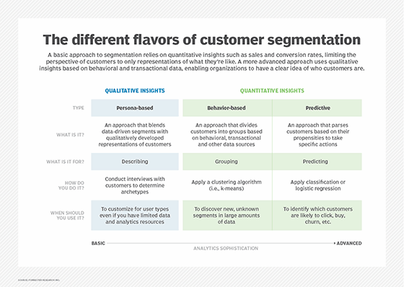

### **IMPORTANCE OF CUSTOMER SEGMENTATION**

### Not only do companies strive to divide their customers into measurable segments according to their needs, behaviors or demographics but they also aim to determine the profit potential of each segment by analyzing its revenue and cost impacts. Value-based segmentation evaluates groups of customers in terms of the revenue they generate and the costs of establishing and maintaining relationships with them. It also helps companies determine which segments are the most and least profitable so that they can adjust their marketing budgets accordingly. Customer segmentation can have a great effect on customer management in that, by dividing customers into different groups that share similar needs, the company can market to each group differently and focus on what each kind of customer needs at any given moment. Large or small, niche customer segments can be targeted depending on the company's resources or needs.

### In B2B marketing, companies are concerned with decision-makers' job titles, the industry sector, whether the company is public or private, its size, location, buying patterns and their technology at their disposal, for example.

### In B2C marketing, companies are concerned with particular customers' profiles, attitudes and lifestyles. B2C companies may also be concerned with geographic location. B2C companies who segment customers based on their geographic location can tailor offers based on regional events and preferences. B2C companies can also customize offers based on the predominant languages spoken in each region.

### Approaches to B2B customer segmentation include vertical or horizontal alignments. In vertical segmentation, companies select certain industries or job titles that would likely find their products appealing and then focus marketing efforts on those segments that they feel are most ready to buy. The benefit of vertical segmentation is that companies can offer services that are fine-tuned to particular industries. The needs of the financial services industry are different from those of the healthcare industry. If each segment was offered services customized to that industry, adoption and satisfaction might increase.

### In horizontal segmentation, companies simply focus on one job title across a wide range of industries and organizations. The benefit of horizontal segmentation is a stronger focus on the needs of particular job titles or job roles. For example, a focus on Chief Financial Officers ([CFO](https://searchcio.techtarget.com/definition/CFO)) can create product collateral, website messaging and email newsletters specifically tailored to that role.

### **CUSTOMER SEGMENTATION VS MARKET SEGMENTATION**

### Companies can use marketing automation software to define and create customer segments. The customer segments can be based on demographic data, psychographic data and activity-based data such as actions that users took on a website. Companies use marketing automation software to configure, schedule and execute campaigns for particular customer segments.

### Customer segmentation is different from market segmentation. An example of market segmentation is grouping customers by the products or services they purchase. A company may perform market segmentation based on distinct lines of business such as software, professional services and training. The company can then allocate resources to each market segment and employ separate marketing and advertising activities to each.